

IT510 Capstone Semester 2 Year 2026
  - Project Title: AI-Enhanced vs Legacy Digital Forensics and Investigation Tools – A Comparative Efficacy Analysis
  - Team Name: Byte Harbor Butchers
  - Team Members: Dave Sushames, Olivia Hey, Matt Baker, Sam Davies
  - Project Client: Geoff Gordon
  - Whitireia and WelTec
Contents
Project Objective 2
Client background 2
Deliverables 2
Technical Requirements 2
Must haves 3
Nice to haves/Stretch Goals 3
Scope 4
Use of AI (LLMs) 5
Project Plan 7
Methodologies 7
Kanban 7
Scrum 7
Design Science Research: 7
Methodology Selected: Design Science Research 8
Tracking Tool: Kanban 9
Testing Method: NIST CFTT 9
Technologies 9
Traditional Digital Forensics Tools being Investigated 10
Tools that were considered 11
Project budget 12
Project Personnel 13
Client Details Including Organisation 13
Group Members 13
Project Advisor 14
Communication plan 15
General Conflict of Interest statement 15
RACI assessment matrix 16
Project timeline and milestones 17
Project Risk Analysis 18
References 21
Appendices 22
Appendix A – Gantt Chart 22
Appendix B – Project Client Contract 23
Appendix C – NDA Requirement 26
Appendix D – Meeting Minutes Example 27
Appendix E – Further Discussion on Tools Not Considered 28
Project Objective

Client background
The client for this project is Geoff Gordon who is a Network Administrator and Senior Technician for WelTec and Whitireia, a local Polytechnic that is a subsidiary of Te Pūkenga – the New Zealand Institute of Skills and Technology. Geoff offers technical support, practical solutions, and helpful ideas to staff, students and lecturers (Whitireia & WelTec, n.d.).
The key problem Geoff would like solved concerns the comparison of traditional digital forensics tools to digital forensic tools that employ a modern Large Language Model (LLM) during forensic artefact discovery/analysis for digital forensics activities. Whether modern Artificial Intelligence (AI) belongs in this domain or not will depend on whether AI-augmented tools use an unreasonable quantity of hardware resources and time to produce at best lesser quality and at worst erroneous forensic evidence. The forensic insights and findings in a report produced by an AI may be below what is expected in a field that demands accuracy and high standards of both ethical and evidentiary integrity.
Geoff is interested in how the performance and findings will compare to that of real human forensic examiners employing the same tools.

Deliverables
The primary deliverable for this project is a research report that presents the findings of human analysts employing three traditional digital forensics tools without any AI assistance on a data source containing digital artefacts of forensic significance, then comparing these results based on performance and quality metrics to be determined with the findings presented by an LLM tasked with conducting a forensic analysis on the same data. The report will document the testing process, metrics used to assess each process, and the resulting comparative findings and recommendations.
In addition to the written report, the project will also produce a video presentation that demonstrates the highlights of the investigation designed to illustrate an investigation from start to finish in a practical capacity to our client.

Technical Requirements
An important primary necessity of this project is that both traditionally employed, and AI-augmented digital forensics tools can be run on a single, locally hosted machine. They will use a shared test case and forensic image/dataset so that both methods of tool application can be tested under the same conditions against the same data. This baseline is important for a fair comparison, since hardware, dataset, and test conditions are variables that will be controlled for a valid experiment to be run.
The required software includes:
-An Operating System to run software (see Kali on page 9)
-A software that can run LLMs locally (see Ollama on page 9)
-Three digital forensics tools (see Foremost on page 10, Nmap on page 10, and Wireshark on page 11)

The team will teach an LLM to ‘understand’ what it is intended to do. This will require designing a prompt; the team will ensure that this prompt is consistent across tests.

Must haves
This investigation will be based upon an array of test cases that the team will develop, for every tool, for both AI and human examiners. Using techniques traditionally used for evaluating the validity of forensic tools and their outputs. This includes volume tests for the LLM to assess their standard deviation on metrics such as accuracy, traceability, and lucidity. The team will also design human investigation environments with independent assessment in mind, building a reliable mean statistic on the performance of human reporters by conducting blind exposure to the forensic datasets. Our digital forensic examiners producing the report will have not already employed the specific tool against the dataset.
A known challenge to LLM integration is inadequate data flow management as it threatens data consistency (Yang, Some, Bain, & Kang, 2025). Because LLMs can only be fed a limited number of data formats, it is anticipated that the team will face LLM challenges with directly using software such as Wireshark due to its specific architecture. However, Nmap will allow output scans directly into a text file which is easily processed. Foremost carves out files of varying types, yet some of them are bound to be incompatible. This integration/interface challenge will be met so that our tests remain wholly impartial in the variable of consistent access to test data from human to LLM.
The final report will include a discussion of which aspects of the digital forensics reporting process and which of our digital forensics tools are enhanced by the introduction of an AI analysis. For example, our report will clearly state whether the resource cost of AI-augmented tool application is justified by enhancements in accuracy, speed, or usability.

Nice to haves/Stretch Goals
An investigation into the ethicality and risk of data leakage with AI-based forensic tools is not strictly required for this project but may present a valuable addition if time allows. Other optional additions include monitoring network traffic during testing to confirm that data is not leaving the network. The team could also conduct testing on larger LLM models, which would require additional equipment such as higher-end GPUs with more memory. Therefore, testing on a dual-GPU setup is considered a stretch goal rather than a requirement.
It may also be useful to establish whether output of a larger model is worth the extra resources it requires, compared to a smaller model. This is because accuracy is an important factor in the production of a forensics report. Determining whether investing more resources produces a higher quality or more usable output may be valuable to the conclusions of this project.
Additional stretch goals include developing scripts or an environment to automate parts of the testing process.
As a final stretch goal, the team could run hybrid tests to see if a human-in-the-loop (HITL) could correct and keep an LLM on track as it investigates. Whether a testing strategy such as this is relevant would depend on the results of our initial tests.

Scope
Tools that can be run in the Kali Linux environment for the intended uses of performing digital forensics against publicly available datasets are within the scope of this project. Forensic testing and analysis will be performed on several datasets. A variety of digital forensics activities such as file/data-carving, memory forensics, network reconnaissance, and network forensics will be considered in-scope for this project. The team will be investigating the performance of these tools against different datasets to display their strengths and weaknesses. The testing of legacy digital forensics tools that can be led by humans and modified/compatible with AI-augmentation are in scope as the team are investigating comparison between two means of tool application. The analysis and documentation of said testing is within scope.
Incident Response (IR) and Digital Forensics (DF) are fields which are closely related, they both involve the discovery and analysis of digital artefacts; however, they tend to utilize different properties of tools. Digital Forensics presents root cause analysis and the mitigation of residual risk to security. This is why the team considers network reconnaissance tools like Nmap to be in scope. The integrity, preservation, and quality of evidence for use in DF activities are variables the team will use to determine how well a tool performs this task. The team will investigate if chains of custody and audit trails are producible by or based on the output of LLM-augmented tool application. Then the use of that tool can potentially enhance accurate documentation/reporting.
Incident Response values the swiftness required to detect, analyse, diagnose, and quarantine during an ongoing security incident. Gathering and consolidating digital evidence during this time is considered DF and assists incident recovery by identifying attack vectors, exploits, indicators of compromise, and attacker identity. For this project, both Incident Response and Digital Forensics are in scope, but may require separate test cases to reflect the quality of their preferred metrics respectively.
The development of our own tools for forensics purposes is not considered within the scope of the project; the team will be using professional tools available on Kali. While a brief discussion on ethics and risk of data leakage is considered a nice to have inclusion, a full investigation into them is outside the scope of this project. Cloud-based tools are also out of scope because the machine the team will be working on is a single locally hosted machine on a local network.
The team is interested in the ability of an LLM to generate reports and come to conclusions based on forensic evidence. An examiner in Digital Forensics employs specialized forensics tools to collect evidence from a range of digital sources and data. In cyber security incident investigations, the evidence retrieved by forensic examiners may be used in a court of law which becomes a foundation for legal proceedings. (PECB, n.d.). A forensics investigator, who could also be the examiner, consolidates this evidence into the report that is displayed in court, or presented to Governance, Risk, and Compliance (GRC) professionals. They produce the big picture and connections between forensic artefacts; they are more concerned with how the evidence fits together and generates criminal liability. Therefore, this project investigates the efficacy of the report output as generated by a human compared to an AI.

Use of AI (LLMs)
The first distinction that is important to define is the differences in technologies that can be categorized under the superset of “AI”.
Figure 1 - Relationships between "AI" technologies
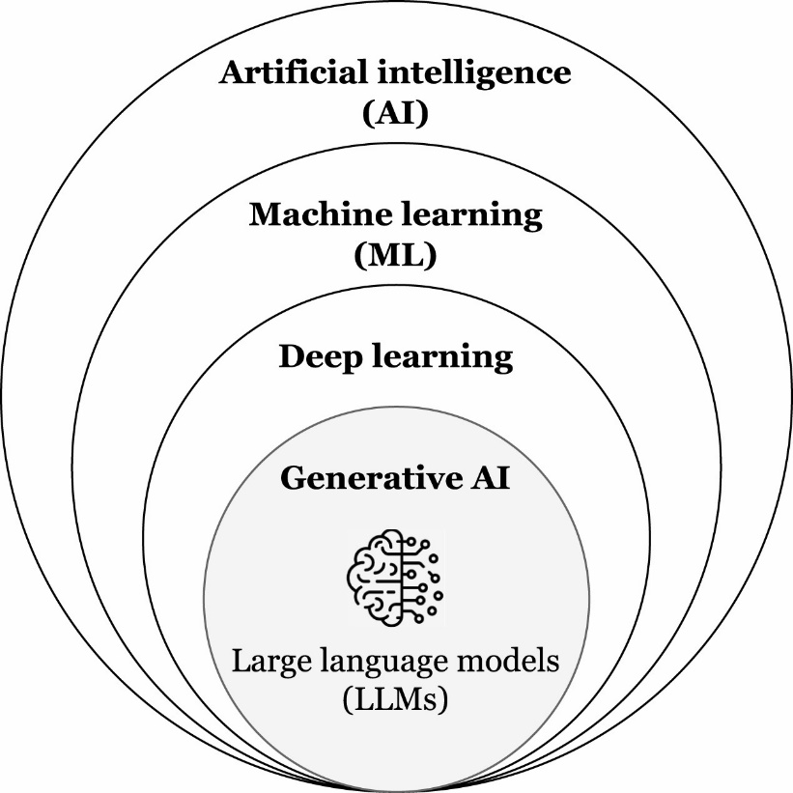
(Baig, Shore, Doss, Syed, & Chernyshev, 2026)
Figure 1 - Relationships between "AI" technologies (page 5) represents the consecutive subsets of AI technologies as they have evolved. Artificial intelligence simply comprises “computational systems designed to perform tasks that typically require human intelligence – such as reasoning, learning, and problem-solving.” (Baig, Shore, Doss, Syed, & Chernyshev, 2026).
Machine learning furthers this effort by training machines to recognize patterns in the pursuit of specific tasks. In DFIR (Digital Forensics and Incident Response), this could be used to automatically report on forensically relevant artefacts within the large quantities of data that are present on hard drive disk images, memory dumps, and mobile phones, such as recognizing indicators of malware based on large quantities of training data.
Deep learning is a further advancement designed to simulate the neural networks in a human brain, this technology is produced by training the system on vast amounts of data to identify patterns to produce predictions by incrementally reducing the difference between “predicted outputs and true outputs” (ISO, n.d.). This could be something like identifying the difference between apples and oranges for 10,000 cycles, this incremental differentiation enforces a strong predictive capacity to the point where the system can identify an orange with a high degree of accuracy.
Generative AI is a subset of deep learning, now the AI can draw or describe an orange by further learning and seek knowledge through other defined sources. (Baig, Shore, Doss, Syed, & Chernyshev, 2026). For our investigation, relevance of this technology could manifest in the AI having the capacity to reference the learned knowledge of international security standards such as ISO27001, threat intelligence databases for example the National Vulnerability Database (NVD), or malware samples. LLM models trained to provide casual communication may present challenges when formatting their report with the expected formal and technical digital forensics language.
Large language models (LLMs), the class of AI that the team is investigating, further develop the computational and algorithmic architectures that recognise patterns from vast quantities of data. They demonstrate novel abilities in “natural language understanding, reasoning, and task generalisation” (Baig, Shore, Doss, Syed, & Chernyshev, 2026). Within the context of the application of LLMs to the output of forensic tools, these capabilities offer the step-by-step contextual processing that could optimize forensic examination and workflow by categorizing and consolidating data retrieval and generating insights. The types of insights the team are investigating could be patterns within the data, suspicious artefacts, or identification of vulnerabilities, payloads, and compromise indicators.
Agentic AI refers to an application of LLMs and Generative AI systems to function with “autonomous, decision making, goal-oriented behaviour, and continuous learning.” (Hosseini & Seilani, 2025) It seems natural that one might seek to apply this technology to the digital forensic reporting process. Digital forensics requires an examiner to sift through massive quantities of data, seeking evidentially relevant artefacts, and following strict evidence handling processes all the while, which delays the workflow. By giving an agentic AI the autonomy to pick tools as it desires and to follow threads of information themselves rather than simply present them with information, they may become more capable of arriving at unique insights. For the controlled investigation the team is conducting, giving our AI models too much autonomy could lead to inconclusive results, therefore this style of generative AI is only likely to appear as an evolution or stretch goal to the project.

How LLMs apply to this project
There are two ways in which a DFIR tool can be considered “enhanced by AI”:
The first is the automation/optimization of outputs generated by existing DFIR tools to produce reports.
This involves filtering the raw outputs of digital forensics tools through an LLM hosted on Ollama (see Technologies section on page 10). The team can interface with LLMs directly on this platform and provide them with data in the form of text files or images. Those LLMs would be commanded and engineered to produce a report and analysis of the given input data (network packet data as would be inspected with Wireshark, carved files as would be produced by foremost, or Nmap scans outputted to file with the -oA flag. The analysis of this forensic data is then assessed as compared to the speed, quality, and quantity of useful insights and forensically relevant artefacts produced by the human DFIR analysts in our team during their investigations into the same data.
The second is an entirely new process of evidence discovery; employing the capacity of an AI model directly to uncover DFIR artefacts given a raw forensic disk image.
Software like this interacts directly with raw forensic disk images and in our assessment are difficult to control and configure, they also do not exist as directly comparable options designed to complete the same tasks as our traditional DFIR tools, and thus, these comprehensive tools are outside of our purview, and therefore out of scope.

Project Plan

Methodologies

Kanban
Kanban is an Agile Methodology which means that it is an approach that divides work into phases, emphasising continuous delivery and improvement, and allows for teams to work simultaneously allowing for greater amounts of work to be delivered in a shorter time than traditional development methodologies such as the Waterfall methodology. Waterfall would require a team to hand off work after the team has completed their part of the project. (Radigan, n.d.) the team have selected Kanban because it is one of the key Project Methodologies used in the current real-world workplaces (Radigan, n.d.). Kanban is a visual workflow management method that will allow the team to better visualize the workload and optimise it according to demand. Kanban works best for the team because it is familiar. Members of the team have used it in previous classes, and it can be integrated seamlessly into this project. It is also a suitable methodology for our topic because it is a research-oriented project. To use Kanban, the team have created a Trello board which allows the team to track all the jobs in this project. Through this Trello board the team can track the jobs inside of three categories, these being “To do”, “In Progress”, and “Done”. These categories help the team to understand what the team have completed, what is in progress, what is still left to do, and allows for the team to keep an idea of how far through our project the team might be and if the team will achieve the desired milestones.

Scrum
Scrum is another development methodology that leverages feedback loops from frequent team meetings and workflows that work together in these feedback loops to get feedback and achieve work completion. Scrum as a development methodology requires a strong degree of trust and commitment from all members of the scrum team, this means that members must be diligent in their workflows and complete work according to schedule in order to ensure that the iterative process is flowing continuously, this means that in order for work to be completed work needs to be completed so that it can be iterated on, the faster this iterative process is completed the faster the project can be completed. How this works is that scrum dictates that there are daily meetings in order for completed work to be evaluated and for new work to be assigned based on the status of completed or in process work, this means that members of the team can be held accountable for work and adjusted for daily in the timeline based on the proposed completion date of work. Scrum works on three pillars, these being transparency, inspection, and adaptation, and finally a bases of trust between leadership and workers. These values ensure that work that is being completed is competent and timely. (Scrum, n.d.)

Design Science Research:
Design Science Research (DSR) is a methodology focused on producing an artefact that solves a problem. These solutions are commonly referred to as artefacts but can be both a physical item or something immaterial such as a framework or guide. Design Science is also typically approached through different forms or framework to guide the working process. The artefact goes through iterations of testing with which can be refined and used to develop the next iteration of the artefact. Knowledge learned and gained through these cycles contributes overall to research and understanding while the iterations aid in producing a quality artefact. (Peffers, Tuunanen, Rothenberger, & Chatterjee, 2007).

Methodology Selected: Design Science Research
The team elected to follow the DSR methodology due to the iterative workflow that sequences well with identifiable artefacts such as the final report, and the ability of DSR to adapt to changes. By using DSRM and through understanding how the methodology and its development process works, the team can develop a quality product by working with our advisors to refine our artefacts to the desired outcome. Figure 2 - Adapted DSR Methodology on page 8 illustrates the process that the team are following in this effort.
Figure 2 - Adapted DSR Methodology
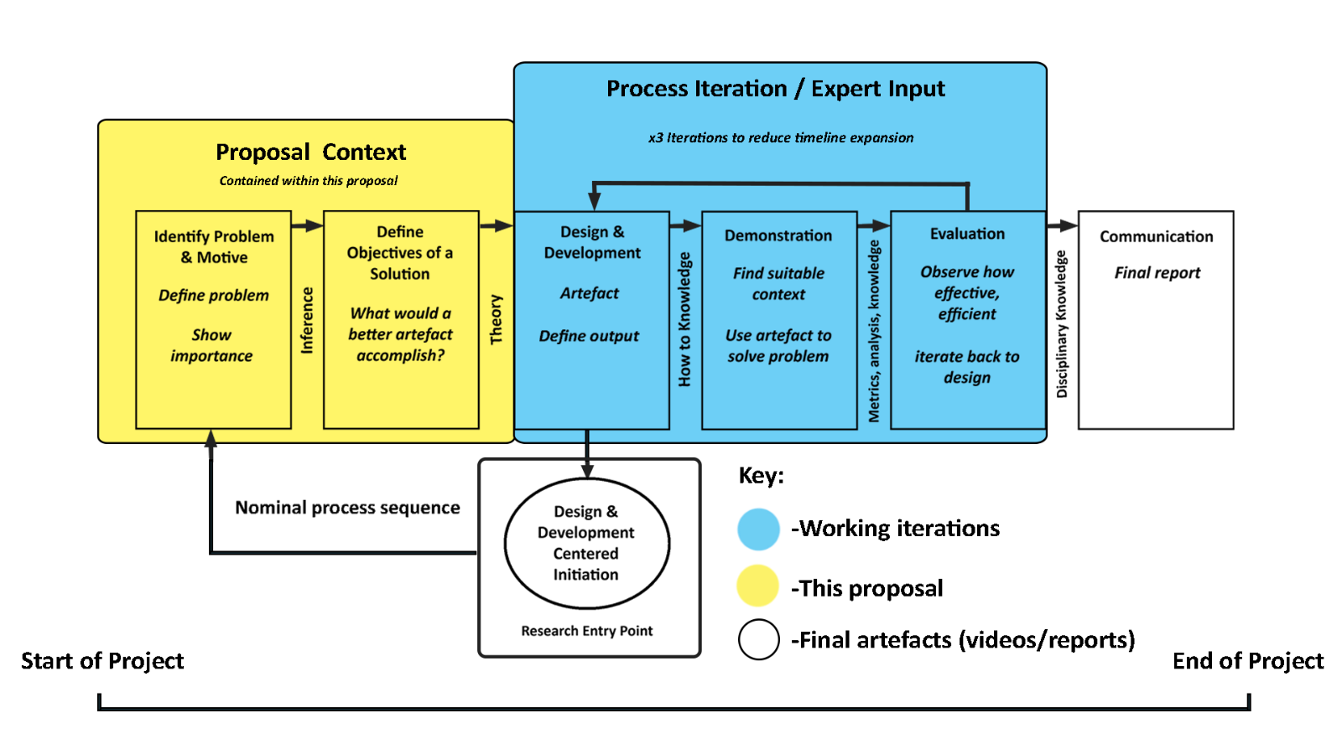

Tracking Tool: Kanban
For this project the tracking tool being used is Kanban because the team felt that the Scrum methodology fit better towards a software development project than it did to a research project. The team also felt that the daily meetings required by Scrum to assess workflows would not suit our team members because of the commitments team members have inside and outside of school which would create conflicting schedules. This affects the arrangement of daily meetings and as such the team thought that simply appropriating the Kanban Trello board and one mandated weekly meeting would better suit our requirements.

Testing Method: NIST CFTT
Whilst NIST CFTT is not a methodology, the team will be utilizing select testing methods. The testing method that the team have selected is the Computer Forensic Tool Testing (CFTT) process. Created by the National Institute of Standards and Technology (NIST), CFTT is a functionality driven testing methodology (NIST, 2026). The team believes that NIST CTFF reflects the requirements of our project because of the nature of research-driven outcomes. The adapted CFTT process is as follows: acquire a tool to be tested, review the tool documentation, select relevant test cases depending on features supported by the tool, develop a test strategy, execute tests, produce a test report, review the test report, client reviews the test report, add findings to a final report. Using this testing process, the team believe that the team can achieve the outcomes required of our project as it is a testing process specific to tool testing.

Technologies
This section of the report will outline the different technologies that will be used during our project. The Technologies included in this section are Kali, which is a Linux distribution, Ollama, GitHub, Discord, OpenVPN, Remote Desktop Connection, Putty SSH, and WinSCP.

Kali
Kali is an open-source, Debian based Linux Distribution which allows users to perform advanced penetration testing and security auditing. Kali is specifically tailored to the needs of experienced penetration testers (Kali, 2025). Kali is therefore the perfect operating system for the team to be using for this project.
The version of Kali the team are using is Kali GNU Linux Rolling 2026.3
https://www.kali.org/

Ollama
Ollama is an application that enables the team to host different LLMs on a local machine. It does this by utilising the VRAM on the graphics cards that the team have supplied to generate outputs. The team have selected Ollama because of its capabilities and compatibility with our project as well as its developer support which has led it to be the better of two assessed options for LLM hosting.
The version of Ollama the team will be using is: Ollama 0.32.9.
https://ollama.com/

GitHub
Our team will be using GitHub repository in order to collate our work, GitHub is a program that allows the team to work from a single repository /directory which makes it easy for the team to keep a single documented project file which can then be submitted as our work at the end of the project. Git versioning provides the team with a clear history of changes and provides a timeline for when work was completed to be presented once the project has been completed.
GitHub link: https://github.com/DavidSushames/BHB-Capstone

Discord
The team will communicate primarily using Discord. Discord is a program that allows users to communicate both orally and over text/images through servers provided by Discord itself. This effectively enables the team to use this space as a constant meeting room that the team can join in and out of according to our day-to-day requirements. This was chosen because Discord is our preferred communication platform that the team are well comfortable and have all used it in the past and will be used to host our team meetings.

OpenVPN, Remote Desktop Connection, Putty SSH, and WinSCP
To securely access the desktop environment of our remote PC setup on the Whitireia WelTec campus, the team are using OpenVPN, Remote Desktop Connection and Putty SSH to access the school network and connect to the IP addresses of the computers. WinSCP will also be used to transfer test case files and reports between our home PCs and the remote test environment.

Traditional Digital Forensics Tools being Investigated
The following is a list of tools that the team have decided are within scope for this project and will be tested and reported on throughout the lifecycle of this project.

Foremost
Foremost is a tool that is used as a digital forensics program to recover lost files based on their header, footer and internal data structures. Foremost works on forensic image files, such as those generated by DD, SafeBack, or EnCase. The team selected this tool because it is a comprehensive data carving tool that generates an output for the team to generate comprehensive reports.
The version being used is: Foremost version v1.5.7
https://www.kali.org/tools/foremost/

Nmap
Nmap is a free and open-source tool for network scanning/network discovery and security auditing. Nmap uses raw IP packets in novel ways to determine what hosts are available on the network, what services (application name and version) those hosts are offering, what operating systems (and OS versions) they are running, and what type of packet filters/firewalls are in use. It was designed to rapidly scan large networks but works well against single hosts. The team selected Nmap due to both our familiarity with the tool as well as the ability of this tool to comprehensively scan networks and provide information on those networks which the team can then turn into reports. Nmap can output scans directly into XML files for LLM consumption.
The version being used is: Nmap v7.90
https://nmap.org/

Wireshark
Wireshark is a network monitoring tool that allows users to see what is happening on their network at a packet level. This enables users to see all the incoming and outgoing traffic to and from their computer as well as the network they are connected to. This means that packets can be inspected for malicious activity and any other nefarious work travelling through their network. The team selected Wireshark because of its ability to scan packets sent through a network, of which the information inside can be turned into reports.
The version being used is Wireshark v4.6.6
https://www.wireshark.org/about.html

Tools that were considered
The following section contains tools that the team have assessed and considered for our project. The team assessed all these tools to figure out what they were, if they functioned, and whether they fit our project. After careful consideration these tools were decided to not be included to keep the workload of our project manageable as well as to not needlessly bloat our project with tools that might not have the impactful results that the project is interested in. Further examples of considered tools not in this project are in Appendix E – Further Discussion on Tools Not Considered on pages 28-29.

HashCat
HashCat is an advanced password recovery utility, supporting five unique modes of attack for over 300 highly optimized hashing algorithms. HashCat is a program/script that cracks passwords, or in other words this program works using the GPU to run different algorithms to solve passwords thus “cracking” them. The team decided against the inclusion of this tool because Hashcat is a tool for password recovery which presents difficulties in quantifying metrics. It is also not a tool that directly links to digital forensics in the capacity that the team is seeking.
The version the team assessed was HashCat v7.1.2+ds1-4
https://github.com/hashcat/hashcat

John The Ripper
John the ripper is an open-source password security auditing and password recovery tool available for many systems. It functions similarly to HashCat and therefore the team decided against the inclusion of this tool because of the same reasons.
The version the team assessed was John the Ripper v1.9.0-jumbo-1+bleeding-aec1328d6c
https://github.com/openwall/john

CyberChef
CyberChef is a simple web app for carrying out all manner of "cyber" operations within a web browser. These operations include simple encoding like XOR and Base64, more complex encryption like AES, DES and Blowfish, creating binary and hex dumps, compression and decompression of data, calculating hashes and checksums, IPv6 and X.509 parsing, changing character encodings, and much more. The tool is designed to enable both technical and non-technical analysts to manipulate data in complex ways without having to deal with complex tools or algorithms. The team decided against the inclusion of this tool because the essential function it provides is encoding and decoding data, meaning that while it is a useful tool it does not have as much depth or impact to DFIR as the team desires.
The version the team assessed was CyberChef v11.3.0 - 2026-07-24
https://github.com/gchq/CyberChef

Volatility
Volatility is a volatile Random Access Memory (RAM) analysis tool that allows a digital forensics examiner to look at processes held inside of computers at the time a “screenshot” of volatile memory is taken, i.e. an image of the machines processes is taken and saved to be processed by Volatility. The team have chosen this tool due to our familiarity with it and because it is a memory forensics tool that can be compared to others that complete similar objectives. Volatility is an excellent tool for volatile memory analysis however the team chose not to include this because for this project because the team are not concerned with analysis on volatile memory and are more concerned with tools that work with less volatile memory.
The version the team assessed was Volatility 3 Framework v2.28.2
https://github.com/volatilityfoundation/volatility3

Project budget
Our project does not require any costs to the client or the team members because all equipment used are either provided by team members, the client, or Whitireia and WelTec. Any software used will be open source and therefore free of charge. The equipment submitted for the project will be returned to the relative owners after the project is completed.

Project Personnel

Client Details Including Organisation
Geoff Gordon is a staff member of WelTec, he provides technical networking expertise in the context of the tertiary environment. He has familiarity, curiosity and deep interest in AI models and their behaviour, as well as their associated hardware/platforms. He is interested in whether AI is has a place in the field of digital forensics. Geoff has been the client on multiple previous IT capstone projects with a focus on AI. One example is an AI chatbot for IT support at the school.

Group Members
This capstone project is being undertaken by four people, this work will manifest in the installation and configuration of tools, LLM integration, the establishment of a testing environment, embarkment of human and LLM-led investigations with our chosen tools, and the analysis on the effectiveness of each tool on each selected case file. The organization of meetings, organization and satisfaction of the methodologies, and consolidation/auditing of individual logs are some other responsibilities. Because the topic of LLMs is novel, and the integration of such technology is outside of our specific expertise, significant research effort is going towards understanding how to practically implement them.
Table 1 - Group members on page 14 specifies the names, roles, and primary duties assigned to each member of the team, and while many of these duties are shared among members, this is justified under the consideration of volume of work, and the particular nature of this project requiring multiple digital forensic investigators.

Table 1 - Group members
Name | Role | Main duties
Matt Baker | Digital Forensics Technician, Video editor | Installation, configuration, research, troubleshooting, and implementation of software/tools/operating systems required to support our investigation. Integration of LLMs into our digital forensics’ tools. Establishing the testing environment and performing forensic activities with legacy and LLM enhanced forensics tools to build comparable reports, recording, measuring, results. Manages directories for each case file and tool. Editing the video presentation of our investigation.
Sam Davies | Digital Forensics Technician + Tester | Testing, documentation, configuration of forensics tools both traditional and LLM based. Undertaking reporting based on the output of traditional tools. Conducts relevant research and testing on relevant tools.
Olivia Hey | Project Manager > Week 6  Digital Forensics Technician | Will serve as the Project Manager from the beginning of Week 7. Documentation, organization of evidence, acquiring forensic disk images and datasets. Partaking in the testing itself via report writing based on traditional tool output. Conducts research into the relevant technologies.  Organises meetings with the client/advisors, ensures the team are keeping to deadlines. Manages the Kanban Trello board.
Dave Sushames | Project Manager < Week 6  Digital Forensics Technician | Served as project manager until the end of week 6. Consolidates individual log hours into the group hours log, manages the git repository, contributes to collaborative documents and conducts research. Manages the test case document.

Project Advisor
The project advisor for this project is Clement Swarnappa.

Communication plan
Table 2 - Communications plan on page 15 presents the names, email addresses, and primary method of contact for all stakeholders involved, it also includes the phone number of our client. While our group internally uses Discord for all team communication, considering the purpose of this project proposal, the primary, relevant, and accessible method of contact for whom it may concern is our emails.
Table 2 - Communications plan
Name | Email address | Primary Method of Contact
Client: Geoff Gordon | Geoff.Gordon@whitireia.ac.nz  (+64) 211576328 | Email
Project advisor: Clement Swarnappa | Clement.Sudhakar@weltec.ac.nz | Email
Group project manager: Olivia Hey | Olivia-hey.hey01@whitireianz.ac.nz | Email
Group member: Dave Sushames | david.sushames@gmail.com | Email
Group member: Matt Baker | mattwillbaker1@gmail.com | Email
Group member: Sam Davies | Samueldavies0220@gmail.com | Email

General Conflict of Interest statement
As our client Geoff Gordon is a member of the WelTec staff, this may be considered a conflict of interest, however, the team have not taken any papers delivered by Geoff. This is because Geoff is not an academic staff member.

RACI assessment matrix
Table 3 - RACI matrix, on page 16, presents the relative responsibility the stakeholders of this project possess with regards to each task. R – Responsible A – Accountable C – Consulted I – Informed.
Table 3 - RACI matrix
Tasks | Geoff Gordon (Client) | Clement Swarnappa (Advisor) | Dave Sushames (PM) | Matt Baker | Olivia Hey | Sam Davies
Installation, management of physical hardware. | R | I | C | C | C | C
Installation/configuration of operating systems, software (Kali, Ollama) and forensic tools (Foremost/Nmap/Wireshark) | C | I | I | R | A | A
Acquisition of forensic datasets/disk images for analysis | I | I | C | C | R | C
LLM integration with digital forensics tools | C | I | C | R | C | C
Creation or adaption of a method (CFTT) and metrics with which to objectively assess the efficacy of our 3 tools and their applications in reports. | C | C | R | A | A | A
Documentation and measuring of results of testing. | C | C | R | R | C | R
Testing in multiple evidence environments (mobile/desktop) on multiple types of target data (Scraped files, Pcap files, foremost output, Nmap scans) | I | I | C | R | C | R
Design a consistent test environment, ensuring all variables are the same and that available processing power is consistent before testing. | I | I | C | R | C | R
Produce an edited video presentation with the highlights of our investigation. | I | I | C | R | C | C

Statement on Appendix B
Appendix B – Project Client Contract on pages 23-25 contains the project-client contract, and includes the determinations made with regards to the rights to the intellectual property produced during this project. It also holds signatures of the relevant stakeholders.

Statement on Appendix C
Appendix C – NDA Requirement on page 26 contains the evidence that an NDA was not necessary for this project, in a written email disclosure with timestamps.

Project timeline and milestones
Table 4 - Main milestones and deliverable dates on page 17 define the project timeline in the form of the significant milestones and dates when deliverable documents are due. It includes the requirements, specific dates they are due, and whether these requirements are intended to serve the client or the capstone paper itself.
Table 4 - Main milestones and deliverable dates
Requirement | Specific date OR academic week of semester | Requirement Type
Written Project Proposal | 7/8/26 | Academic (artefact)
Video: Proposal evidence of meeting | 7/8/26 | Academic
Final version of Proposal | 28/8/26 | Academic (artefact)
Begin development | 31/8/26 | Client
Mid project Progress Presentation | 15/9/26 | Academic | Client
Writing findings for document | 28/9/26 | Client
Self-management review | 5/10/26 | Academic
Client Demo | Week 14 | Client
Client Report | Week 15 | Client (artefact)
Client Conducting Review | 19/10/26 | Client
Client Closeout report | 19/10/26 | Academic (artefact) | Client (artefact)
Academic closeout report | 19/10/26 | Academic (artefact)
Academic poster + 1 pager | 19/10/26 | Academic (artefact)
Upload PPT for Final Panel | 31/10/26 | Academic
Final Panel | Week 16 or 17 | Academic
Weekly Logs | Weekly, due Wednesday 1pm | Academic

Project Risk Analysis
Table 5 - Risk assessment matrix on page 18 is a severity/likelihood matrix that illustrates the quantitative relationship between the potential for a risk to occur, and its likely damages to the project in case of occurrence. This assists the team in prioritizing and designing contingency around the risks with the highest relative severity in relation to their likelihood, such as missed deadlines.
Table 5 - Risk assessment matrix
 | Severity
Likelihood | 1 - Insignificant | 2 - Minor | 3 - Significant | 4 - Major | 5 - Severe
5 - Almost Certain |  | R04 Formatting inconsistencies
4 - Likely | R15 Version control conflicts. |  | R02 Team member becomes unavailable. | R01 Missed deadlines.
3 - Moderate |  | R12 Internet outage. | R05 Misunderstood requirements.  R06 Software difficulties.
2 - Unlikely |  | R14 Power outage. | R09 Client becomes unavailable.  R10 Advisor becomes unavailable.  R11 Tech/Vendor becomes unavailable. | R07 Hardware stolen.  R08 Data/File loss or corruption. | R03 Academic integrity violation.
1 - Rarely |  |  |  |  | R13 Natural disaster or pandemic.

Table 6 - Risk mitigation plan (page 19) places these risks into a list specifying the measure to mitigate the likelihood of each respective risk. Table 7 - Risk contingency plan (page 20) demonstrates as a list the actions to be taken if mitigation efforts fail and a risk comes to pass.

Table 6 - Risk mitigation plan
Risk | Mitigation
R01 Missed deadlines | Have regular team meetings to check team progress, see what is lacking.  Break work into set milestones with internal deadlines.
R02 Team member becomes unavailable | Ensure multiple team members can do the same tasks. Keep documentation current and have required tasks be visible for the whole team.
R03 Academic integrity violation | Clearly attribute any external code, sources, and AI tool use. Individual contributions tracked via commit history so authorship can be verified.
R04 Formatting inconsistencies | Agree on a style/template before writing begins. Do a formatting pass before each submission.
R05 Misunderstood requirements | Confirm requirements in writing after each client/advisor meeting. Review minutes with the team.
R06 Software difficulties | Research/experiment with new tools early, before committing to them. Choose tools with good documentation and/or team familiarity.
R07 Hardware stolen | Keep PC in locked network room, in an inconspicuous location. Label components with the name of the owner. Keep photo proof of ownership.
R08 Data/File loss/corruption | Regular backups should be done in multiple locations. Regularly commit/push to Git.
R09 Client becomes unavailable | Get requirements and scope signed off early, so project can continue even without ongoing client input.
R10 Advisor becomes unavailable | Keep written records of advisor meetings so the project is not reliant on any single conversation.
R11 Tech/Vendor becomes unavailable | Use established, actively maintained tools where possible. Have backup options in case one tool goes down.
R12 Internet outage | Have a backup communication method (phone/text) for if discord/zoom is unreachable.
R13 Natural disaster or pandemic | Make sure the majority of work can be completed from home and does not require onsite presence.
R14 Power outage | Save work frequently. Keep a laptop with files synched to it so that work can continue if power goes out.
R15 Version control conflicts | Everyone works in separate files, then copies the whole section into the main document once done. Communicate before editing the main document.

Table 7 - Risk contingency plan
Risk | Contingency actions
R01 Missed deadlines | Urgent team meeting to reprioritise, meet with client to discuss cutting scope. Inform advisor if final deadline is at risk.
R02 Team member becomes unavailable | Redistribute the tasks of missing members to the rest of the team. Inform advisor if unavailability is for an extended period. Possibly request scope adjustment.
R03 Academic integrity violation | Notify advisor/coordinator. Team member responsible admits fault.
R04 Formatting inconsistencies | Do a pass before each submission to ensure consistent formatting.
R05 Misunderstood requirements | Book urgent meeting with client/advisor for clarification. Revise documentation for requirements.
R06 Software difficulties | Ask advisor for guidance. If software is too difficult to work with, fall back to an easier alternative tool.
R07 Hardware stolen | Report to WelTec and police. Contact client, advisor, and possibly coordinator for further steps.
R08 Data/File loss/corruption | Notify team urgently, attempt to recover from most recent Git commit. Inform project advisor if loss is significant.
R09 Client becomes unavailable | Continue work according to last signed off requirements. Inform advisor/coordinator.
R10 Advisor becomes unavailable | Escalate to course coordinator for advice. Continue work according to last agreed requirements in the meantime.
R11 Tech/Vendor becomes unavailable | Switch to an alternative tool or last available open-source version. Inform client/advisor if functionality impact is significant.
R12 Internet outage | Fall back to phone/text to stay coordinated. Work offline, or tether/hotspot using mobile data to stay online.
R13 Natural disaster or pandemic | Shift all work to fully remote. Hold all meetings online instead of in person.
R14 Power outage | Switch to laptop while battery lasts, continue work where possible. Sync changes once power restored.
R15 Version control conflicts | Resolve conflict with merge tools within Git. Affected team members should discuss which lines to keep.

References
Atlassian. (n.d.). What is Agile? Retrieved from Atlassian: https://www.atlassian.com/agile
Baig, Z., Shore, M., Doss, R., Syed, N., & Chernyshev, M. (2026, October 26). Large language models in digital forensics: capabilities, challenges and future directions. Retrieved from https://www.sciencedirect.com/science/article/pii/S2666281725001830#fig0010
Bhelonde, T. (2026, March 15). What Is LM Studio and What Are Its Use Cases? Retrieved from Digital Citizen: https://www.digitalcitizen.life/what-is-lm-studio-and-what-are-its-use-cases/
Hosseini, S., & Seilani, H. (2025, July). The role of agentic AI in shaping a smart future: A systematic review. Retrieved from https://www.sciencedirect.com/science/article/pii/S2590005625000268
ISO. (n.d.). Deep learning: The mechanics of magic. Retrieved August 31 from ISO: https://www.iso.org/artificial-intelligence/deep-learning
Kali. (2025, June 18). What is Kali Linux? Retrieved August 31 from Kali: https://www.kali.org/docs/introduction/what-is-kali-linux/#about-kali-linux
Koppenhagen, N., Gaß, O., & Müller, B. (2012). Design Science Research in Action - Anatomy of Success Critical Activities for Rigor and Relevance.
NIST. (2026, May 1). Computer Forensics Tool Testing Program (CFTT). Retrieved from NIST: https://www.nist.gov/itl/csd/secure-systems-and-applications/computer-forensics-tool-testing-program-cftt/cftt-general-0
PECB. (n.d.). Certified Digital Forensics Examiner – Training Course. Retrieved August 31 from PECB: https://pecb.com/en/education-and-certification-for-individuals/certified-digital-forensics-examiner#first
Peffers, K., Tuunanen, T., Rothenberger, M. A., & Chatterjee, S. (2007). A Design Science Research Methodology for Information Systems Research. Journal of Management Information Systems, 45-77.
Radigan, D. (n.d.). What is Kanban in project management? Breaking down the methodology. Retrieved August 31 from Atlassian: https://www.atlassian.com/agile/kanban
Scrum. (n.d.). What is Scrum. Retrieved August 31 from Scrum: https://www.scrum.org/learning-series/what-is-scrum/
Whitireia & Weltec. (n.d.). Our Staff. Retrieved August 31 from whitireiaweltec: https://www.whitireiaweltec.ac.nz/about-us/staff-profiles
Yang, W., Some, L., Bain, M., & Kang, B. (2025). A comprehensive survey on integrating large language models with knowledge-based methods. Hobart: University of Tasmania. Retrieved from https://www.sciencedirect.com/science/article/pii/S0950705125005490

Appendices

Appendix A – Gantt Chart
Planned distribution and approximate timeline of work to be done.
Figure 3 - Gantt Chart
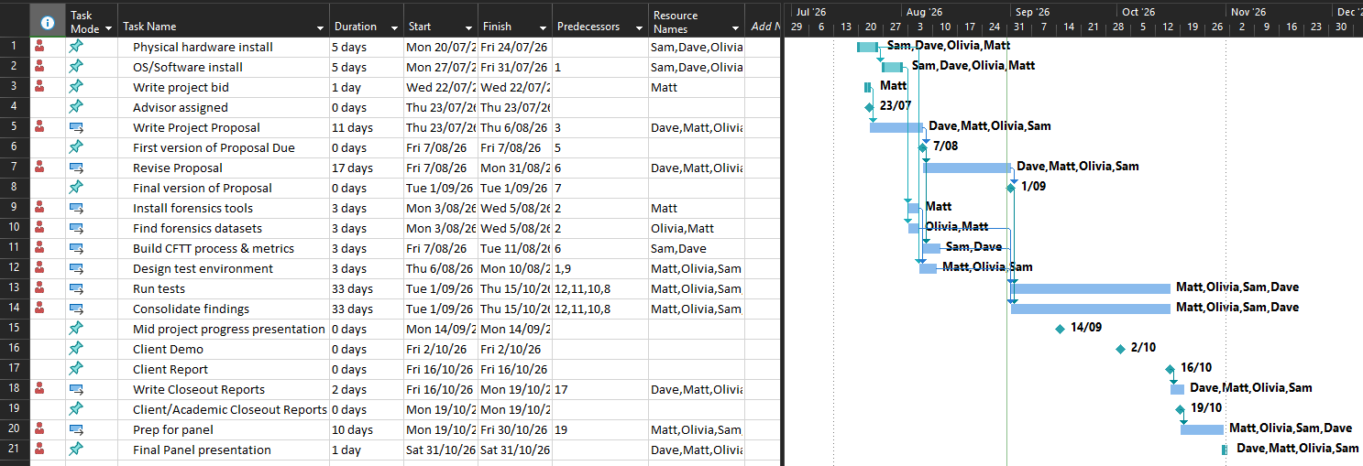

Appendix B – Project Client Contract
IT7510 Project Client Contract

WHITIREIA and WELTEC NEW ZEALAND
SCHOOL OF INNOVATION, DESIGN and TECHNOLOGY
PROJECT AGREEMENT

The Parties

This Student(s) Project Agreement (the “Agreement”) is made between:
- Whitireia and Weltec New Zealand School of Innovation, Design and Technology
(the “Faculty”);
- the nominated computing student(s) (the “Student(s)”) (as listed under section 6); and
Geoff Gordon the proposed Industry Organisation (the “Organisation”).

BACKGROUND

- As part of an established course of study at the Faculty, Bachelor of Information Technology students take a course module IT7x01, in which the Student(s) completes a project (“the Project”) with the Organisation on the basis set out in this Agreement.
- The Organisation agrees to allow the Student(s) access to its premises if needed to undertake that Project on the basis set out in this Agreement.
- The Faculty is satisfied that the Organisation is suitable for the Student(s) Project.

TERMS

1. Effective Date

This Agreement shall be effective as of ____________________ until ________________

2. Undertakings

2.1 The Organisation has accepted the Student(s) and agrees to allow that Student(s) access to its premises as needed.
2.2 The Organisation agrees to be responsible for meeting the requirements of its statutory obligations, e.g. Health and Safety in Employment Act, Human Rights Act, etc., for the Student(s).
2.3 The Student(s) will use their best efforts in undertaking the Project for the Organisation, as mutually agreed by the parties and set out in a separate written proposal which will form part of this Agreement.
2.4 The Organisation understands that the primary reason for the Project is education and advancement of knowledge, and, consequently, the Project must further that purpose.
2.5 Neither the Faculty nor the Student(s) guarantee specific results and the Project will be undertaken only on a best efforts basis.
2.6 The Student(s) agrees to submit their IT7510 report to their nominated supervisor at the Organisation.

3. Copyright, Patents, Trade Marks and other Intellectual Property Rights
The Faculty and Student(s) each acknowledge that all copyright, trademarks, trade names, patents and other intellectual property rights belonging to the Organisation that the Faculty and Student(s) come into contact with are and shall remain the sole property of the Organisation, and no claim or right to them is to be made by or created in the Faculty or Student(s).

4. Confidential Information
4.1 The parties may wish, from time to time, in connection with the Project undertaken under this Agreement, to disclose certain information of a confidential nature (“Confidential Information”) to each other. Each party will use reasonable efforts to prevent the disclosure of any of the other parties Confidential Information to third parties for a period of three (3) years from receipt of that information, provided that the recipient party’s obligation shall not apply to information that:
- is not disclosed in writing or reduced to writing and marked with an appropriate confidentiality legend or designated in writing as Confidential Information within thirty (30) days of disclosure;
- is already in the recipient party’s possession at the time of disclosure;
- is or later becomes part of the public domain through no fault of the recipient party;
- is received from a third party having no obligations of confidentiality to the disclosing party;
- is independently developed by the recipient party; or
- is required by law or regulation to be disclosed.
  - Application may be made to any party for written permission to use Confidential Information.
No party shall unreasonably withhold such permission.
  - If permission to use Confidential Information is withheld by a party, then that party will state the reason or basis for refusal of permission.

5. Intellectual Property Rights
5.1 The parties agree that both the Faculty and the Student(s) may use the intellectual property rights that are created as a result of the Project work undertaken by each Student for the Organisation for portfolio purposes to promote the Faculty and/or the Student(s).
5.2 The following intellectual property rights are agreed between the parties:
(Please indicate which option is agreed upon by placing a tick in the appropriate box and deleting the options that do not apply.)

Option 3 – Split Ownership
There shall be two types of intellectual property:
• Custom property (being intellectual property specifically developed by the Student(s) for the Organisation)
• Generic property (being any intellectual property not specifically developed by the Student(s) for the Organisation)
The Custom property will be vested solely in the Organisation whereas Generic property will vest solely in each respective Student. Each Student hereby grants the Organisation and where more than one Student has been involved in the Project, the other Student(s), a perpetual non-exclusive licence for that Generic property.

6. Signatures
Project Name: AI vs Legacy Digital Forensics Tools – A Comparative Efficacy Analysis
 | Role | Name | Signature | Date
Project Client  Organisation  Representative |  | Geoff Gordon
Representative of Whitireia New Zealand/ Faculty
Representative
Student | Project Manager | Olivia Hey
Student | Developer/Researcher/Tester | Matt Baker
Student | Developer/Researcher/Tester | Sam Davies
Student | Developer/Researcher/Tester | Dave Sushames

Appendix C – NDA Requirement
Geoff did not require an NDA to be signed.
Figure 3 - Confirmation of no NDA required
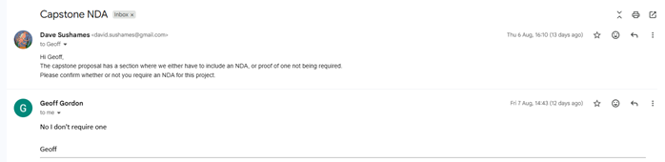

Appendix D – Meeting Minutes Example
From Week 3 Group Log:
Final project outcome
- Report is not enough
- Suggests the team talk to Geoff about the final outcome and what he expects to get out of it
- Suggests the team ask a lot of questions
- Research and create proposal to Geoff so the team can discuss requirements
Research different project methodologies
- Dave should make a Gantt chart on Microsoft project
- Gantt chart is a live document
- The team should begin with a WBS and network (?) and then do the Gantt chart so it is optimized
- Is a dynamic document
GitHub is not exclusive to programming, can upload any files
- Research how to use GitHub for storing our data and document changes.
- How to use git for our proposal?
- Reiterates research.
Dave needs to reply to emails
- Have a meeting with Geoff next week and draft 1 of proposal by Thursday 12 next week to go over with Clement next week.
- Produce work output of hours you do.
- Recommends AI to sort research topics.
- Dave is to build an agenda for meetings and send the notes to Clement beforehand.
Meeting ended at 2pm

Appendix E – Further Discussion on Tools Not Considered

Sherloq
Sherloq is an open-source digital image forensic toolset which enables users to engage with images and see if images have been edited or not. Though it is not autonomous, it is designed to be a companion in experimenting with various algorithms found in the latest research papers and workshops, meaning this tool is more of an expression of self than a project designed to fix a problem. This tool is therefore to be used with caution and an open mind in terms of its functionality. This option was explored during the initial stages of our project however the team ultimately decided against it because the scope of our project does not include imagery.
The version the team assessed was Sherloq v0.94F
https://github.com/GuidoBartoli/sherloq

TruFor
TruFor is a tool based on a forensic framework that can be applied to a large variety of image manipulation methods, from cheap fakes to more recent manipulations based on deep learning. In short, this program works to provide statistical information regarding potentially manipulated images as it provides an integrity score afterwards that can help inform the users decisions on whether or not the image has been manipulated. This tool was also overlooked because it works with images in a similar vein to that of the previous tool.
The version the team assessed was TruFor commit ae54475df6f41a491d7615100feb19263dec13f7, Date: Thu May 29 09:46:01 2025 +0200
https://github.com/grip-unina/TruFor/tree/main

PassLLM
PassLLM is essentially an LLM which uses Personally Identifiable Information (PII) – such as names, birthdays, phone numbers, emails and previous passwords to predict passwords that targets are likely to use. The LLM uses this information and guesses passwords based on the information it has and supposedly outperforms other models by 15% to 45% in most scenarios meaning that this is a potentially capable system. This tool was initially selected as it uses LLMs to work out passwords, however this tool was overlooked because of similar reasons to the other password cracking tools.
The version the team assessed was PassLLM v1.3.0
https://github.com/Tzohar/PassLLM

Unearth
Unearth is a digital forensics investigation platform designed to help examiners uncover hidden or deleted information from digital systems, it combines data recovery techniques with intelligent content analysis in a single environment. The platform can recover deleted files from modern file systems and analyse recovered data and assist investigators in understanding what happened in a system. The team decided against the use of unearth because it functions similarly to foremost and because it would not function. The team decided to use Foremost instead.
The version the team assessed was Unearth version v1.0.0
https://github.com/bhargavgajare1479/Unearth

Valhuntir
Valhuntir is an AI augmented but human-driven program that turns a single incident response analyst into the manager of an agentic AI incident response team. A host of MCP tools allows for the AI to quickly ingest, process and analyse massive amounts of digital forensics artefacts while keeping the human in control of the investigation and decision-making process. This means that despite being an AI tool it allows for the human in control to drive the process and steer it into the deliverables the human is seeking to achieve. The team had opted to test Valhuntir however decided not to use it because it uses a different operating system to the one selected for our work machine and therefore could not get it to function.
The version the team assessed was Valhuntir v0.6.1
https://github.com/AppliedIR/Valhuntir

Unfold
Unfold is a tool that functions by using the volatility3 script to run memory analysis, it does this by running a script that invokes a python shell for volatility3 where the user can input the commands to receive the desired outcomes. This application is allegedly packaged with AI functionality however it seems that this is packaged in a manner that requires it to be outsourced to OpenAI or DeepSeek which leads the team to believe that it is not the most secure tool. Unfold was a tool the team selected because it looked to have great capabilities when analysing volatile memory, it uses functionality from volatility3 and repackages it into a new tool that has AI integrations for plain text prompts using a tool call, however, Unfold is seemingly a broken student project that did not work and therefore could not be used.
The version the team assessed was Unfold v3
https://github.com/arazazi/UNFOLD

Autopsy
Autopsy is the premier open-source forensics platform, which is fast, easy to use, and capable of analysing all types of mobile devices and digital media. Its plugin architecture enables extensibility from community developed or custom-built modules. Autopsy evolves to meet the needs of hundreds of thousands of professionals in law enforcement, national security, litigation support and corporate investigation. The team considered using autopsy however it was decided against in favour of more uniform tools that have clear functions as these would be easier to quantify.
The version the team assessed was Autopsy v2.24
https://www.autopsy.com/

ExifTool
ExifTool is a platform independent command line application for reading, writing, and editing meta information in a wide variety of files, this primarily can be used for editing metadata. The team have decided not to use ExifTool because the information that it provides is not as important or useful as the other forms of data that will be used after being found using their respective tools.
The version the team assessed was Exif Tool v13.55
https://exiftool.org/

LM Studio
LM Studio is another LLM hosting application that functions similarly to Ollama but contained in a GUI. It was opted against because it does not have all the capabilities needed.
The version of LM Studio the team assessed was LM Studio 0.4.21
https://lmstudio.ai/

